Electronic Supplementary Information (ESI) for
Revised Manuscript: Org. Biomol. Chem. (Article B306473P)

Fig. S1 Behaviors of TE14005 (a), TE14011 and Ac-TE14011 (b) in mouse serum. (a) HPLC peak areas (%) of the starting material (TE14005) and the degraded product (des-Arg14-TE14005) were shown with the passage of time (h). (b) The peak areas of TE14011 and Ac-TE14011 were not significantly changed for 24 h. All data are the mean values for at least two experiments.
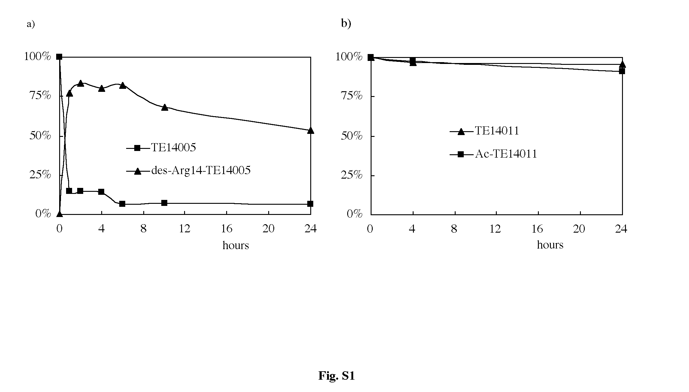

Fig. S2 Behaviors of TE14011 (a), Ac-TE14011 (b), TN14003 (c), Ac-TN14003 (d), TC14012 (e) and Ac-TC14012 (f) in rat liver homogenate. (a, c, e) HPLC peak areas (%) of the starting material (TE14011, TN14003 or TC14012) and the degraded products (des-[Arg1, Arg2, Nal3]-parent peptide, Nal, des-[Arg14-NH2]-parent peptide) were shown with the passage of time (h). (b, d, f) HPLC peak areas of the starting material (Ac-TE14011, Ac-TN14003 or Ac-TC14012) and the degraded product (des-[Arg14-NH2]-parent peptide) were shown with the passage of time. All data are the mean values for at least two experiments.
